Eind OPlevering

OIT11 2018

Naam: Bram van Gils PCN: 401949

Contents

Module 1.1 2

Opdracht 4.2 2

Opdracht 4.3 3

Module 2.1 5

Flow-Chart 5

Code 5

Module 3.1 8

Code 8

Module 3.2 – 3.5 9

Flow-Chart 9

Code: 10

Variabelen en CheckPaused Method 10

CalibrateValues Method 10

PowerMotors + StopMotors Method 10

Evade Method 11

Main Method 11

Bronnen 12

# Module 1.1

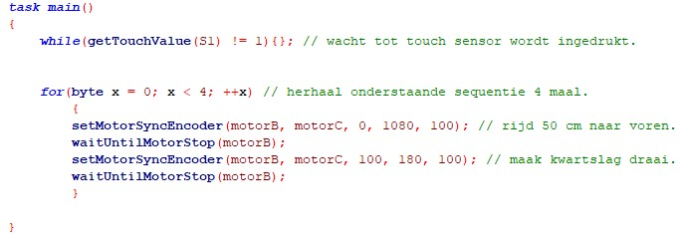

# Module 1.2

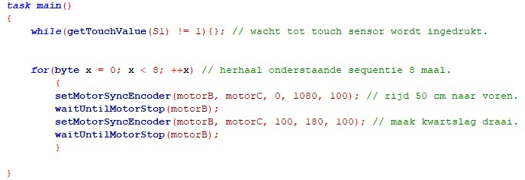

# Module 1.3

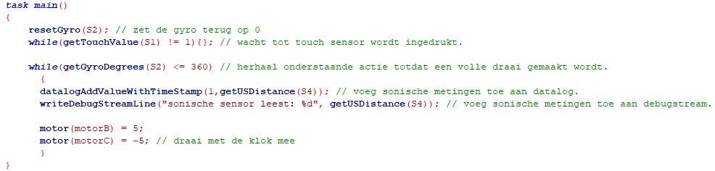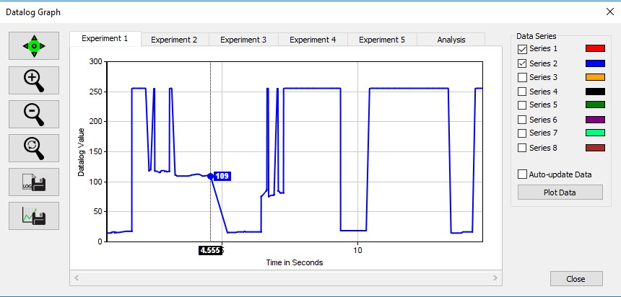

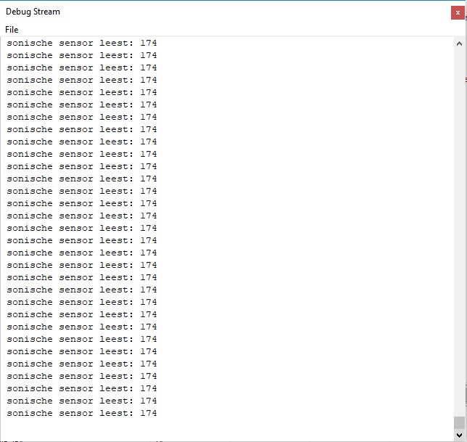

(Resultaten lijken op elkaar omdat de sensor 16.610 metingen heeft gemaakt)

# Module 2.1

## Flow-Chart

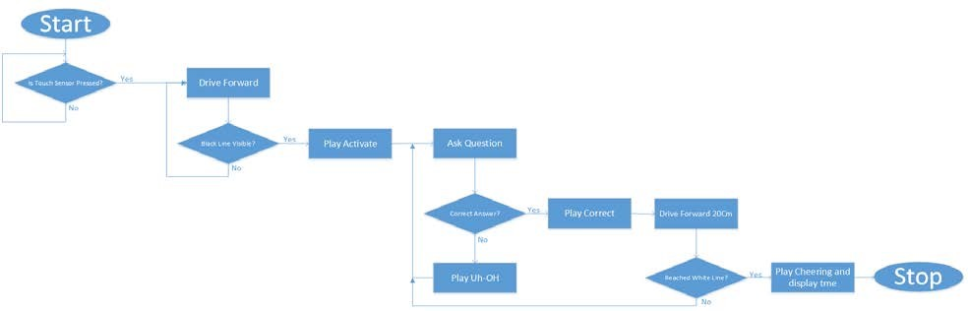

Link voor betere weergave <https://drive.google.com/open?id=1B-lYXPB1uSaZpWDp1faIoIwQOYql-Dz8>

## Code

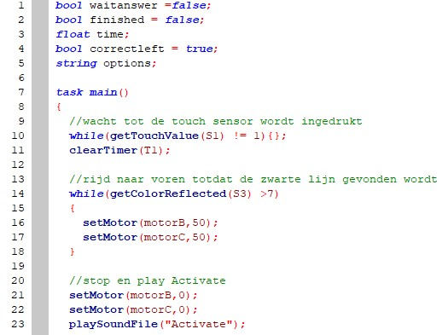

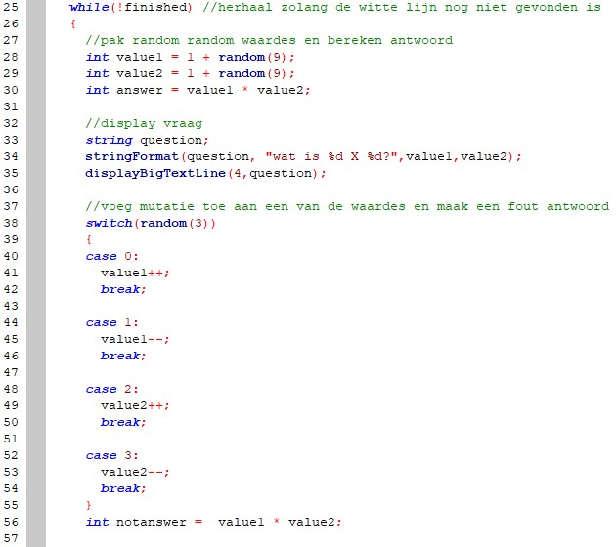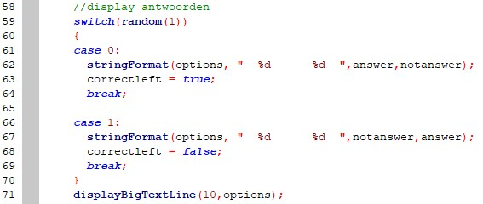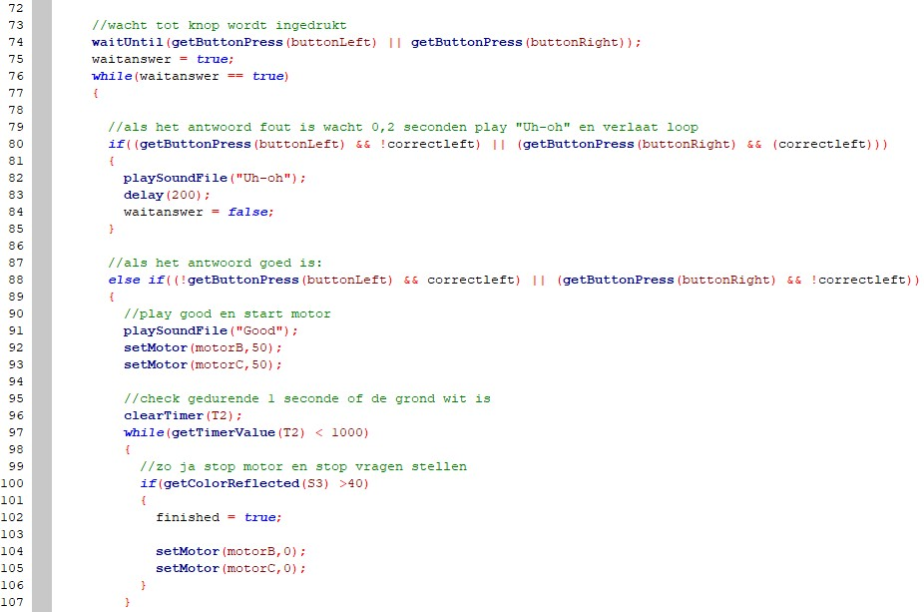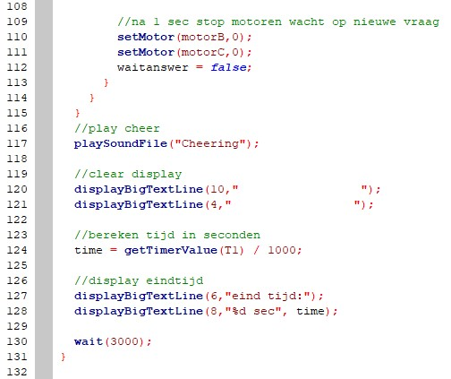

# Module 3.1

## Code

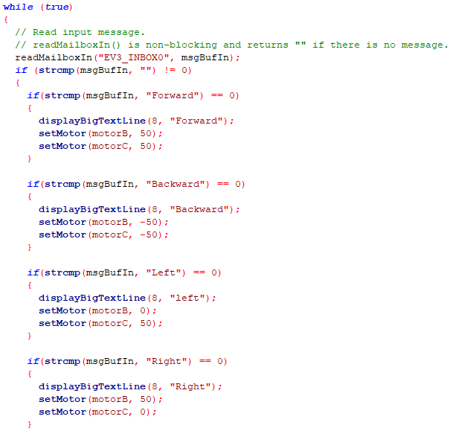

# Module 3.2 – 3.5

## Flow-Chart

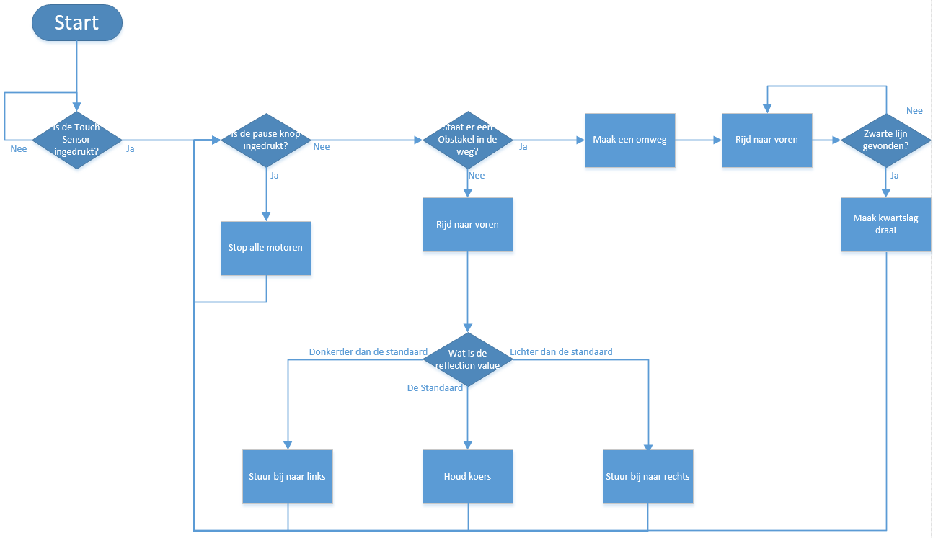

Link voor betere Weergave: <https://drive.google.com/open?id=1mMaBmnQnCb5VIEaaypnY8kOFj9mnrW-c>

## Code:

### Variabelen en CheckPaused Method

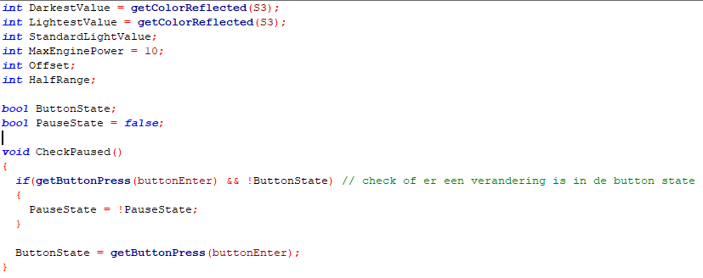

### CalibrateValues Method

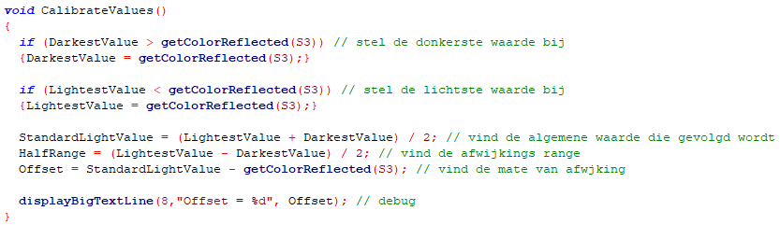

### PowerMotors + StopMotors Method

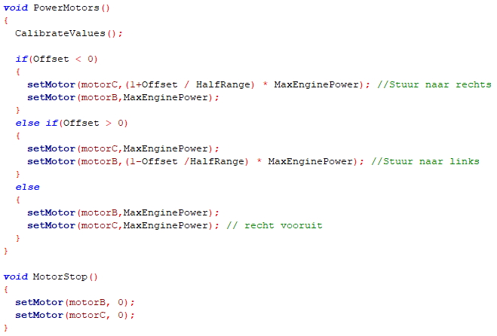

### Evade Method

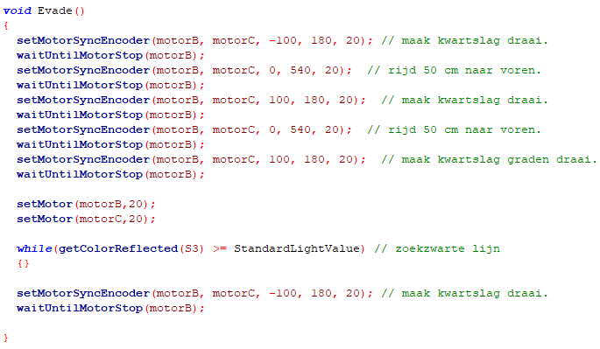

### Main Method

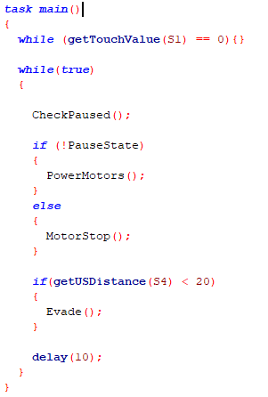

# Bronnen

[http://help.robotc.net/WebHelpMindstorms/Content/Resources/topics/LEGO_EV3/ROBOTC/Motors/se tMotorSyncEncoder.htm](http://help.robotc.net/WebHelpMindstorms/Content/Resources/topics/LEGO_EV3/ROBOTC/Motors/setMotorSyncEncoder.htm)

[http://www.robotc.net/wikiarchive/Tutorials/Arduino_Projects/Mobile_Robotics/VEX/Using_encoders_ to_drive_some_distance](http://www.robotc.net/wikiarchive/Tutorials/Arduino_Projects/Mobile_Robotics/VEX/Using_encoders_to_drive_some_distance)

[http://help.robotc.net/Sandbox/Zendesk-](http://help.robotc.net/Sandbox/Zendesk-Output/Content/Resources/topics/VEX_IQ/ROBOTC/Datalogging/datalogAddValueWithTimeStamp.htm)

[Output/Content/Resources/topics/VEX_IQ/ROBOTC/Datalogging/datalogAddValueWithTimeStamp.htm](http://help.robotc.net/Sandbox/Zendesk-Output/Content/Resources/topics/VEX_IQ/ROBOTC/Datalogging/datalogAddValueWithTimeStamp.htm)

<https://stackoverflow.com/questions/822323/how-to-generate-a-random-number-in-c><https://stackoverflow.com/questions/2751406/while-with-multiple-conditions>

[https://sites.google.com/site/ev3basic/ev3-basic-programming/using-buttons-the-screen-and-theleds/lego-ev3-standard-bitmapshttps://msdn.microsoft.com/en-us/library/f355wky8.aspx](https://sites.google.com/site/ev3basic/ev3-basic-programming/using-buttons-the-screen-and-the-leds/lego-ev3-standard-bitmapshttps:/msdn.microsoft.com/en-us/library/f355wky8.aspx) <https://msdn.microsoft.com/en-us/library/f355wky8.aspx><https://www.tutorialspoint.com/cprogramming/c_break_statement.htm>

[http://help.robotc.net/WebHelpVEX/index.htm#Resources/topics/ROBOTC_Debugger/Debug_Windows /Motors.htm](http://help.robotc.net/WebHelpVEX/index.htm%23Resources/topics/ROBOTC_Debugger/Debug_Windows/Motors.htm)

<https://www.youtube.com/watch?v=BjVeWRNiddE>

<https://stackoverflow.com/questions/16627588/what-is-the-correct-string-terminator-in-c>

<https://www.tutorialspoint.com/cprogramming/c_arrays.htm>

<https://www.le.ac.uk/users/rjm1/cotter/page_22.htm>

<https://www.tutorialspoint.com/cprogramming/c_variables.htm>

<https://www.geeksforgeeks.org/understanding-extern-keyword-in-c/>

<https://stackoverflow.com/questions/15707732/what-does-array-means>